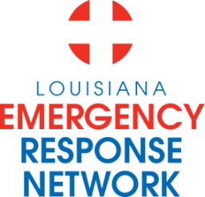

Louisiana Emergency Response Network
Board Meeting
January 15, 2015
1:00pm – 3:00pm
Location: Louisiana Emergency Response Network - Headquarters
14141 Airline Hwy, Suite One, Suite B Baton Rouge, LA 70817

AGENDA
1. Welcome LERN Board Members
2. Roll Call and Establish a Quorum
3. Approval of Agenda
4. Approval of Minutes of 11/20 Board Meeting
5. LERN Business:
- Ratification of Commission Members P. Hargrove

b. Executive Director Report P. Hargrove
- Strategic priority review

c. Stroke Update Sheryl Martin-Schild, MD
- Update
- Rule promulgated

d. STEMI Update Paige Hargrove
- Update
- Rule promulgated

e. Trauma System Update R. Coscia, MD
- Level 4 Trauma Centers
- Region 8 Trauma Center Development J. Owings, MD

f. LERN Communication Center J. Allemand
- 2014 Call Center Data

g. Budget/Finance P. Sullivan/C. Woods
- Reductions

h. Dr. Hunt Report/Closing Remarks J. Hunt, MD

6. Public Comment
7. Adjournment
Next Board Meeting – April 16, 2015

